**Pre-Lab 11:**

**MOSFET Amplifier Configurations**

Name: Wan-Yu Liao

ECEN 325 Section 514

TA: Mandela

Date: November 15, 2019

**Calculation**

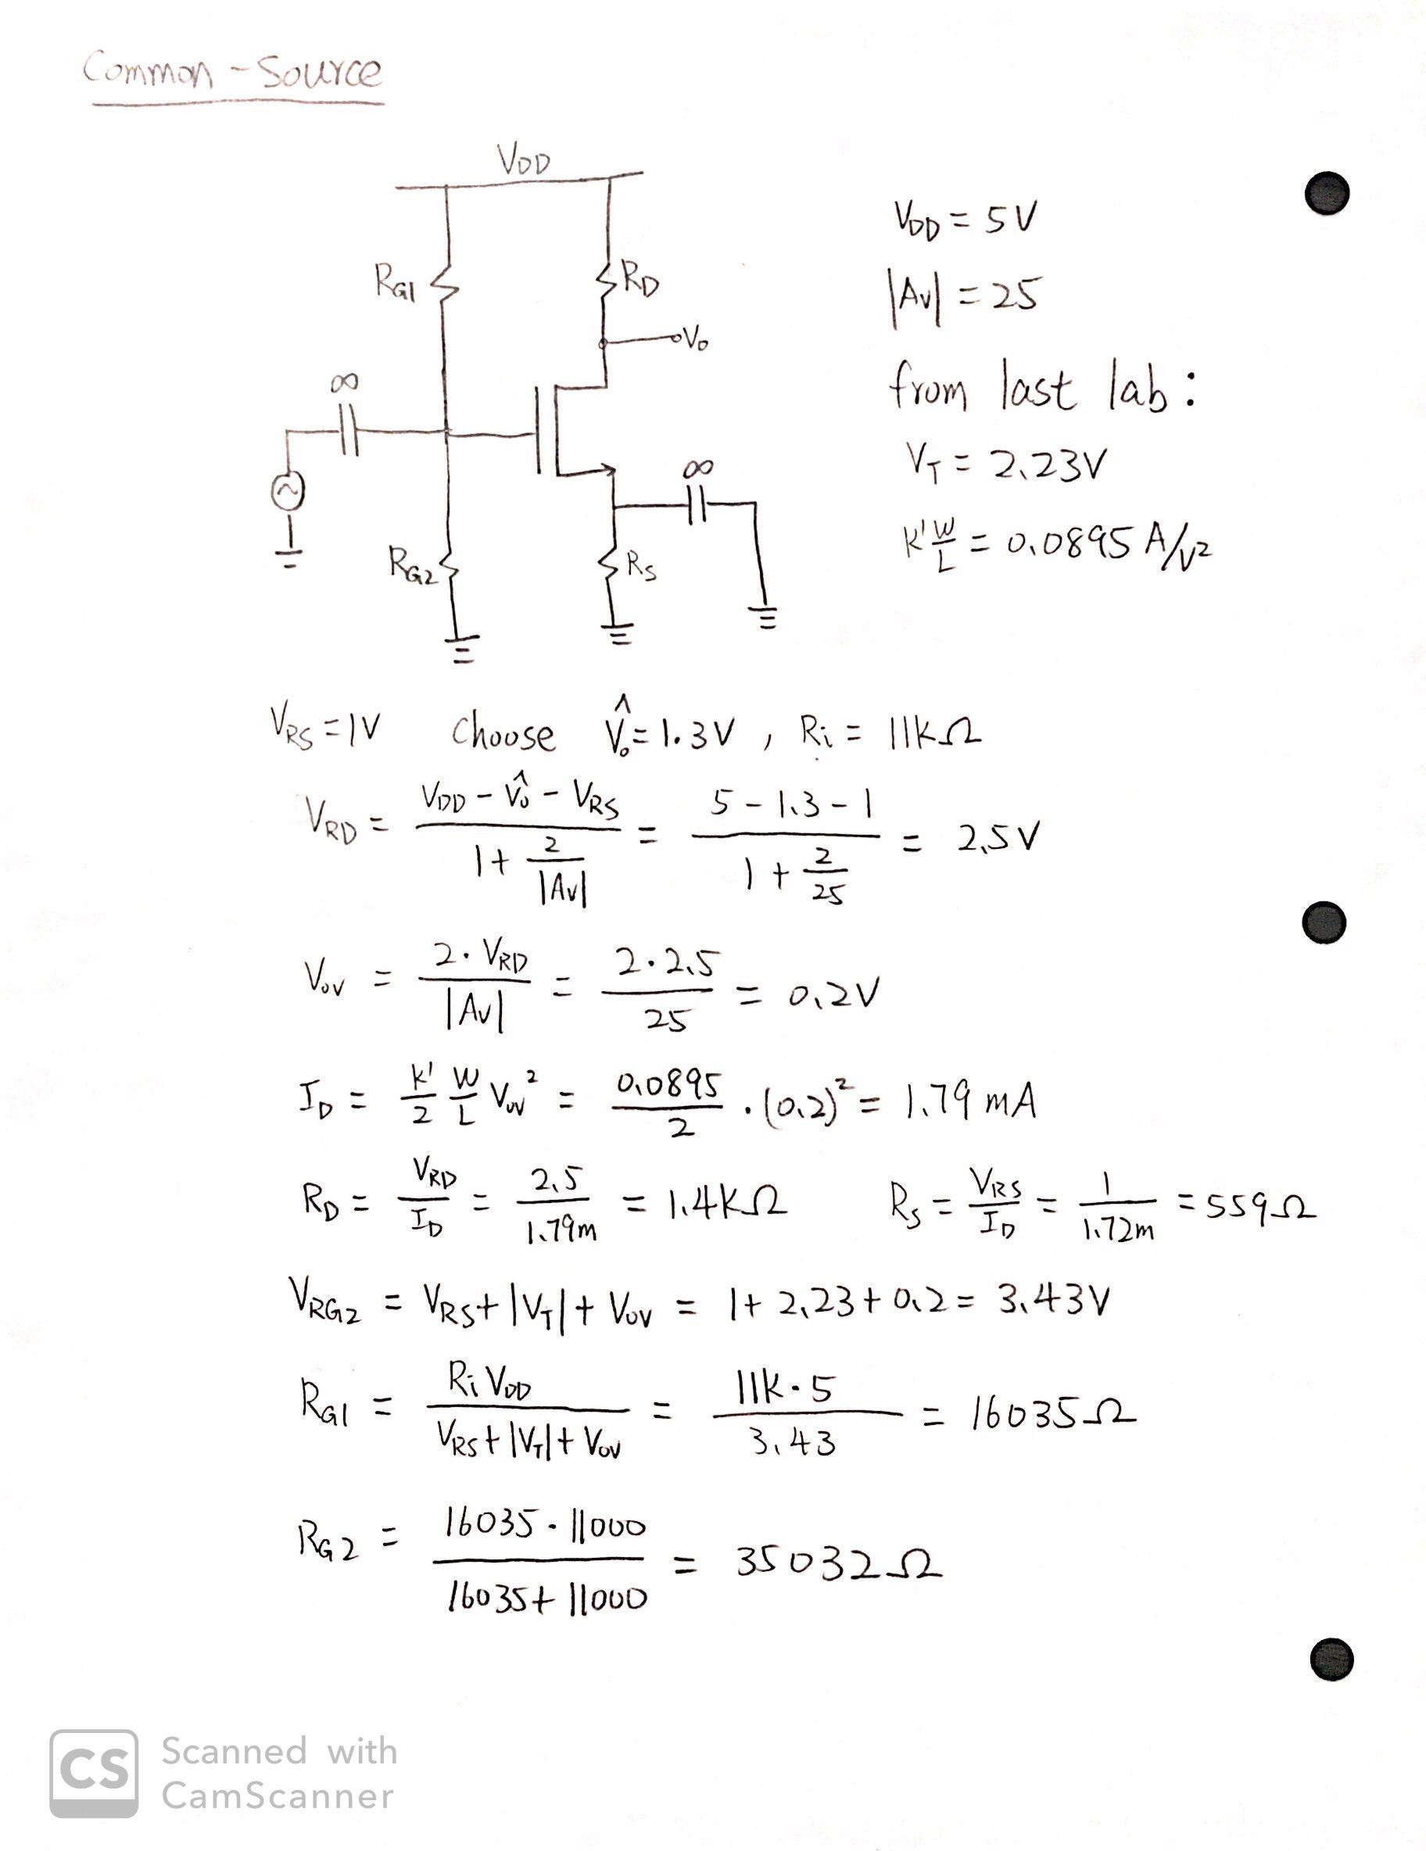

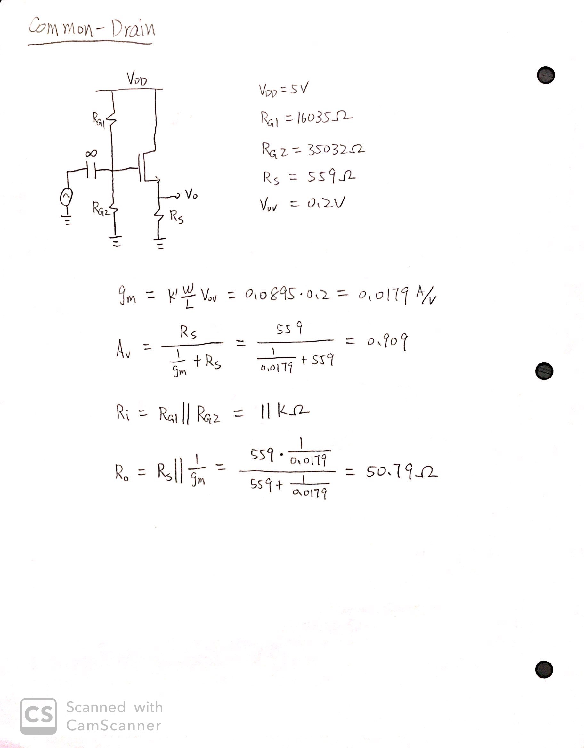

**Simulation**

Common-Source Amplifier

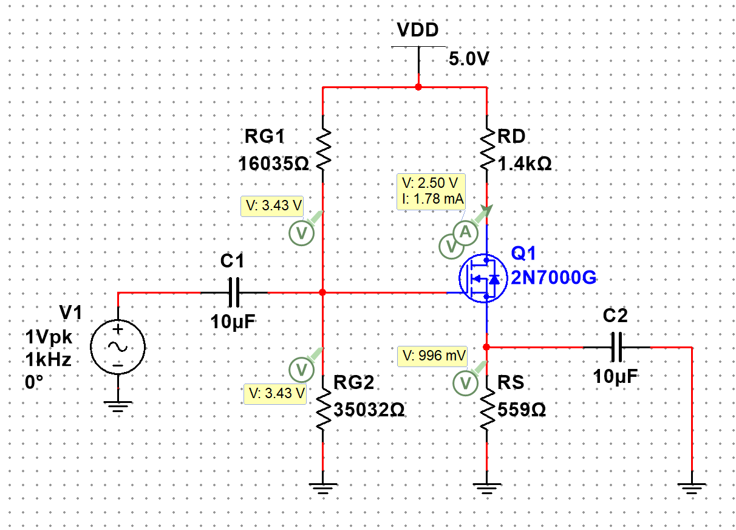

**Figure 1:** DC Solution for common-source amplifier ▲

VRG2 = 3.43V

VRS = 0.996V

VRD = 5-2.5 = 2.5V

Vo,dc = 2.5V

ID = 1.78mA

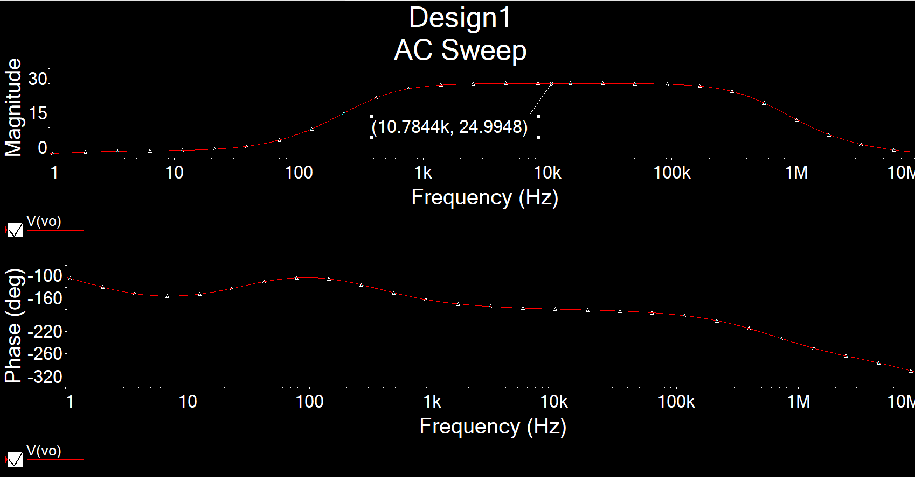

**Figure 2.1:** AC Simulation of AV for common-source amplifier ▲

AV = 24.9948

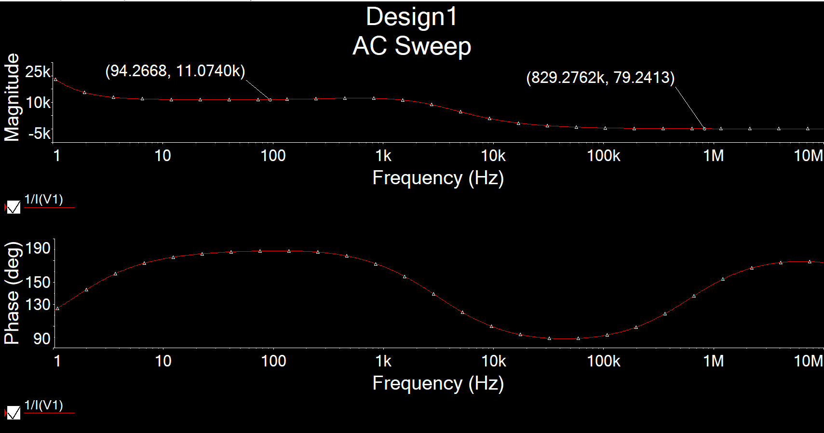

**Figure 2.2:** AC Simulation of Ri for common-source amplifier ▲

Ri = 11.0740kΩ

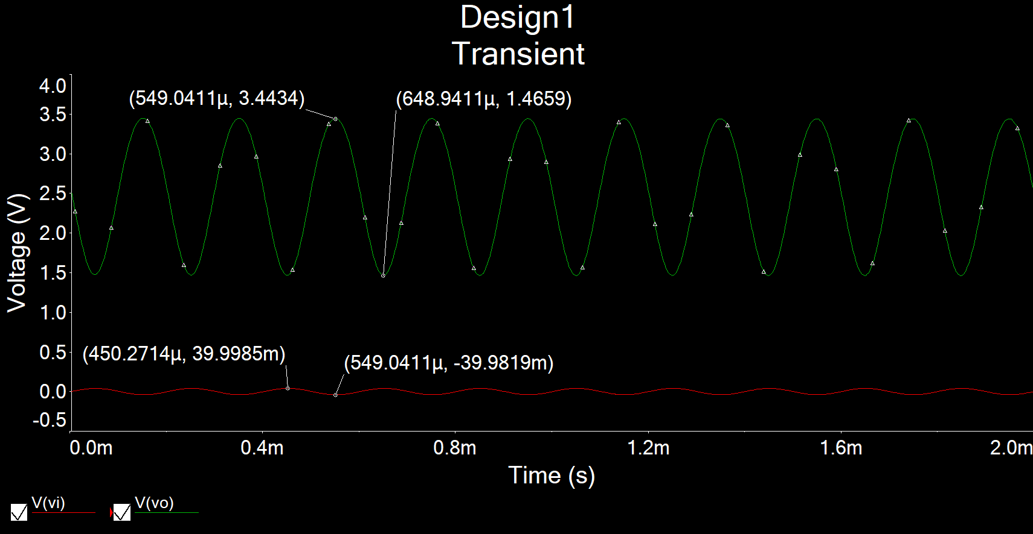

**Figure 3:** Time-domain waveform of Vi = 40mVfor common-source amplifier ▲

AV =

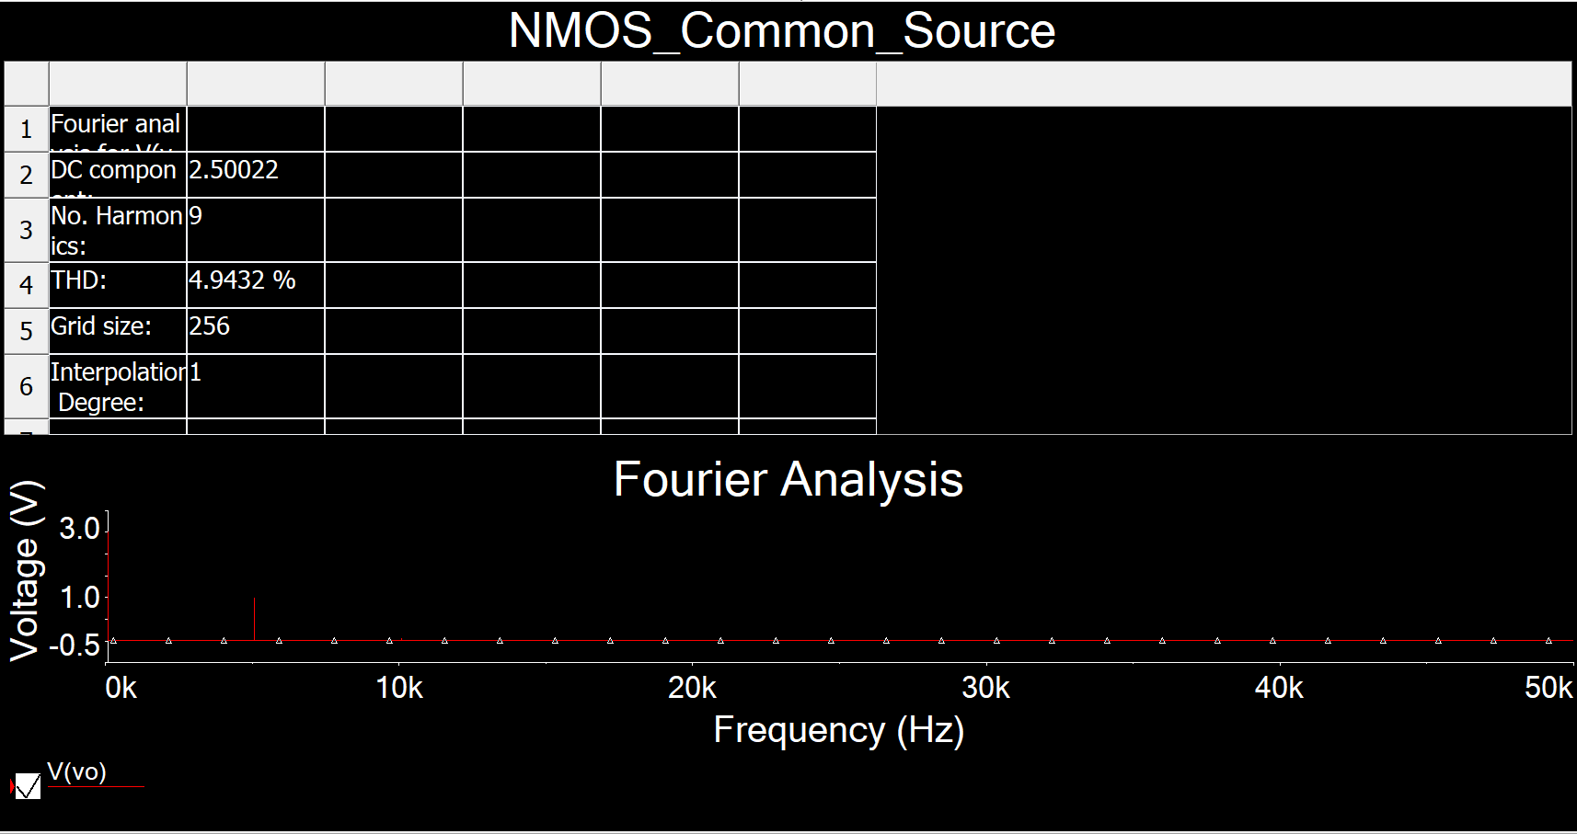

**Figure 4:** Total harmonic distortion (THD) for common-source amplifier ▲

THD = 4.9432% ≤ 5%

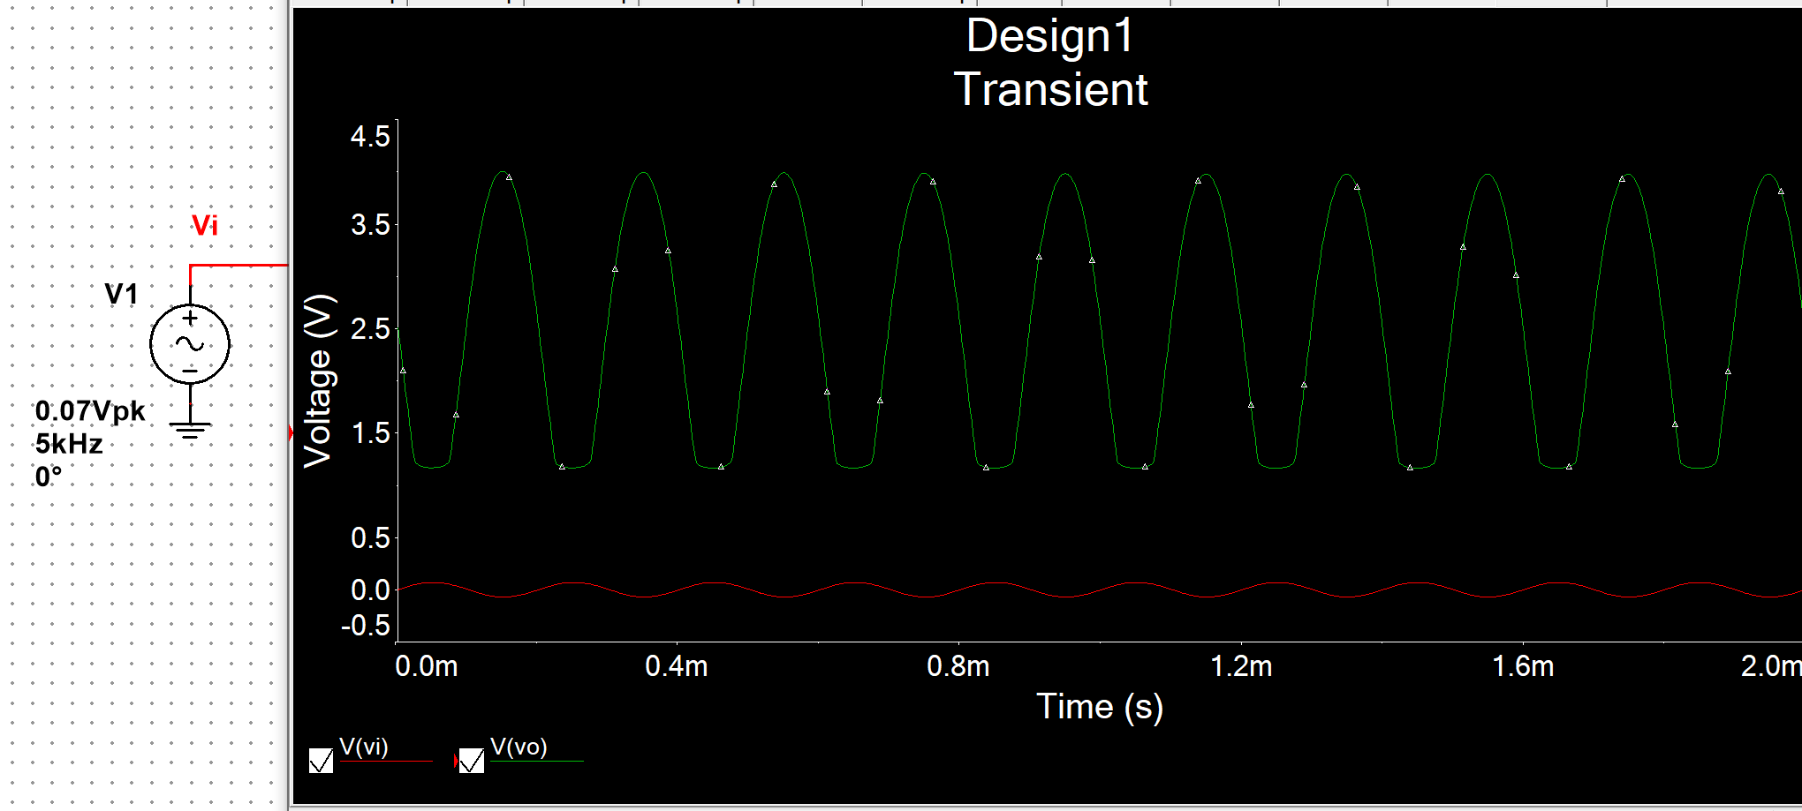

**Figure 5:** Clipping voltage for common-source amplifier ▲

Clipping voltage = 70mV

Common-Drain Amplifier

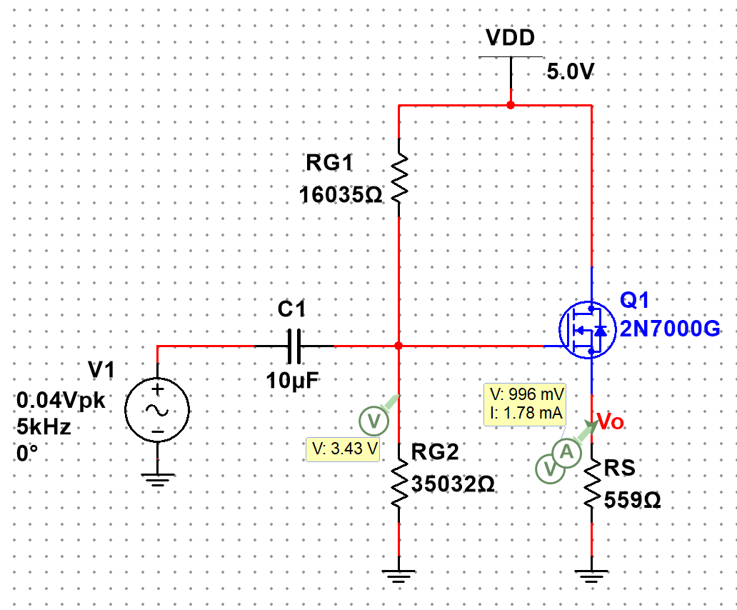

**Figure 6:** DC Solution for common-drain amplifier ▲

VRG2 = 3.43V

VRS = 0.996V

ID = 1.78mA

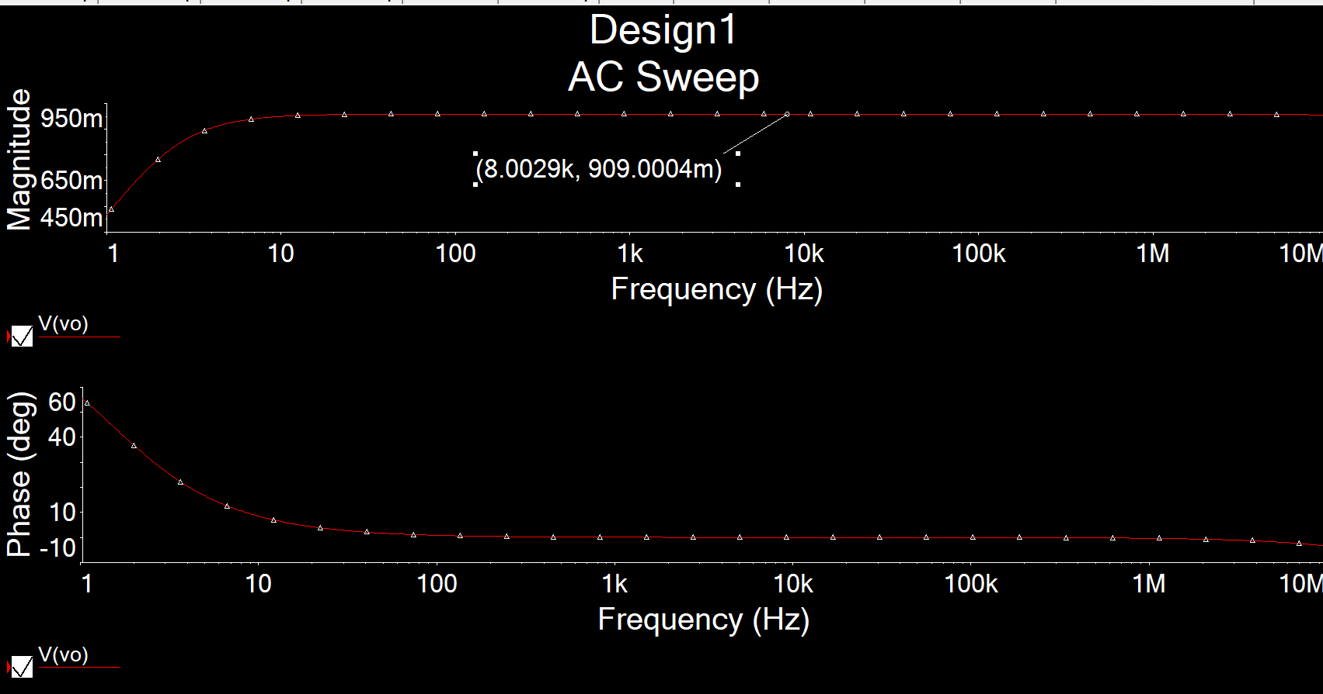

**Figure 7.1:** AC Simulation of AV for common-drain amplifier ▲

AV = 0.909

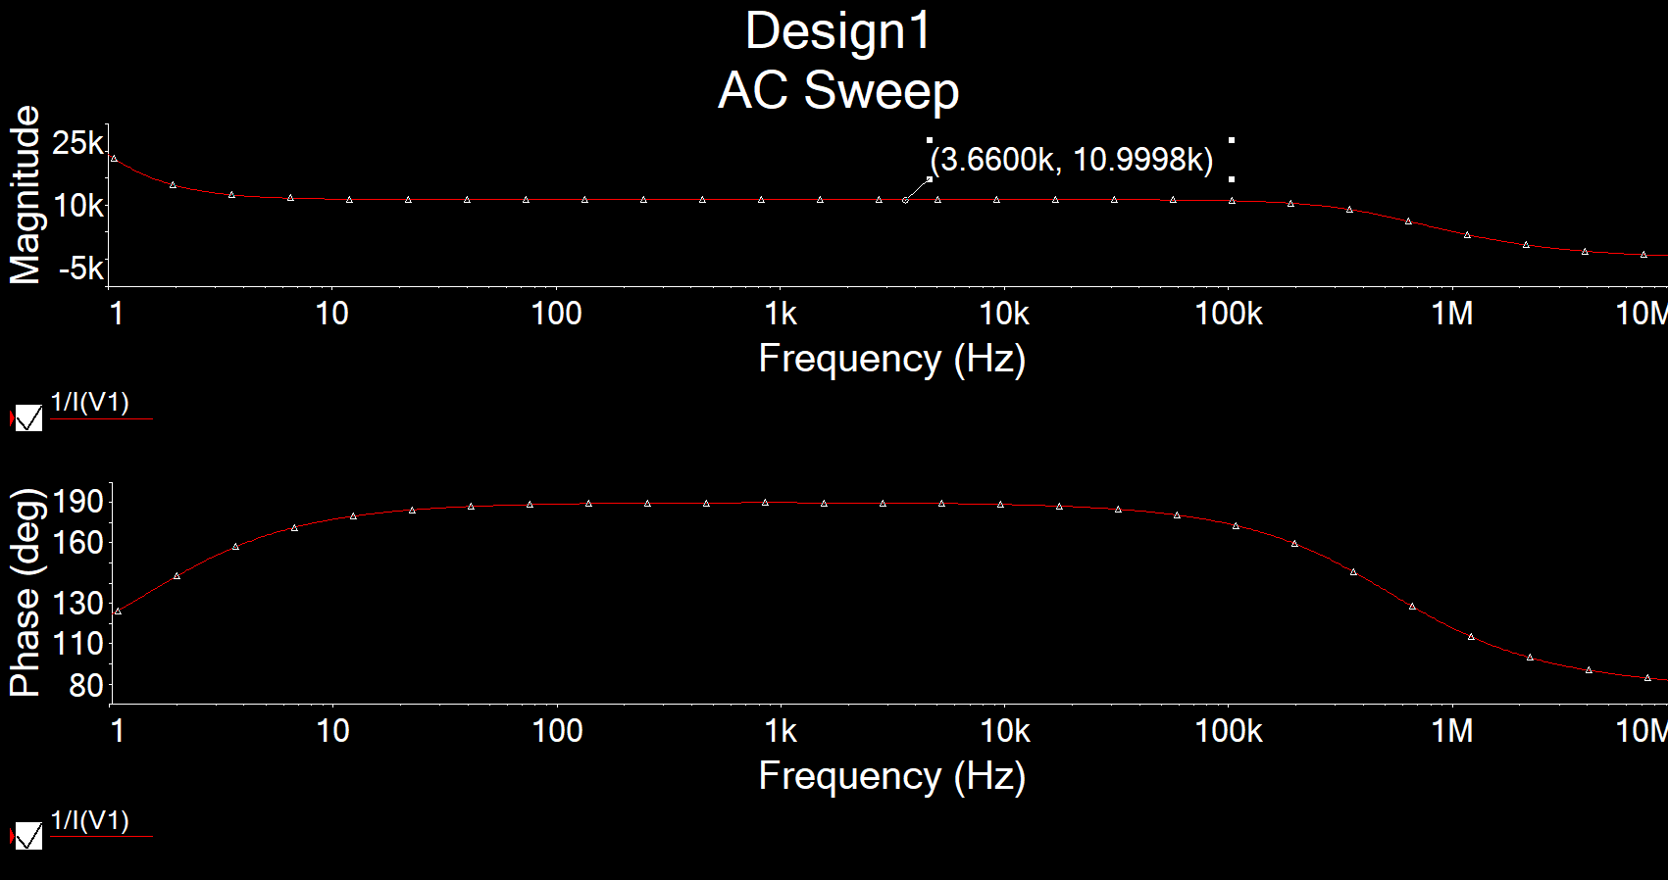

**Figure 7.2:** AC Simulation of Ri for common-drain amplifier ▲

Ri = 10.9998kΩ

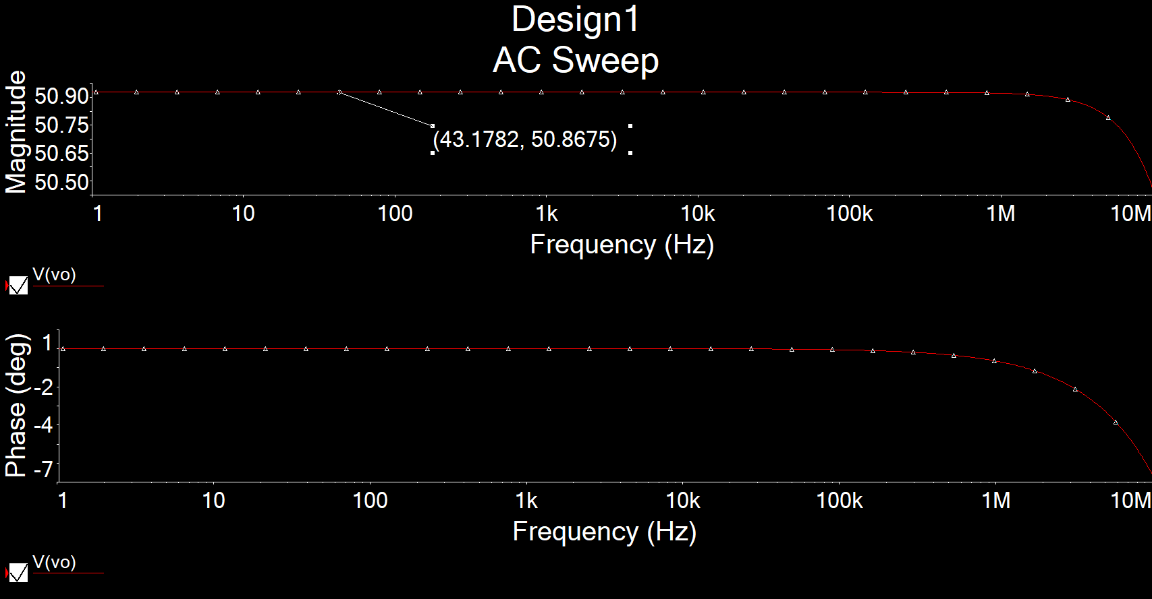

**Figure 7.3:** AC Simulation of Ro for common-drain amplifier ▲

Ro = 50.8675Ω

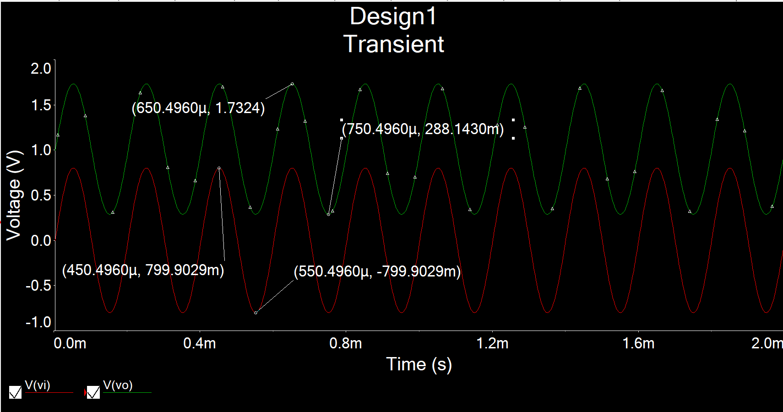

**Figure 8:** Time-domain waveform of Vi = 0.8Vfor common-drain amplifier ▲

AV =

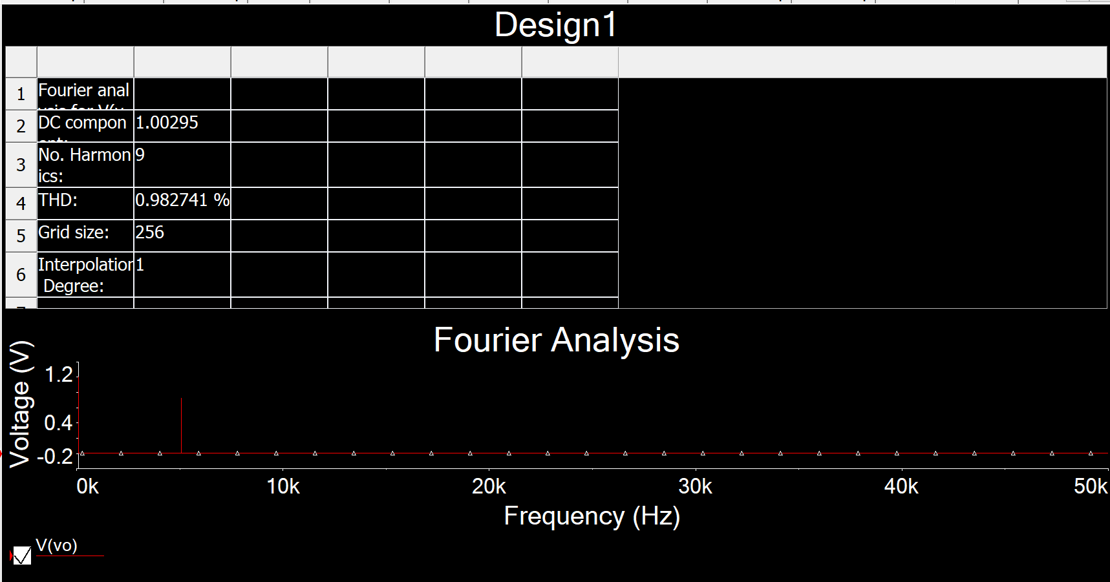

**Figure 9:** Total harmonic distortion (THD) for common-drain amplifier ▲

THD = 0.983%

**Table**

**Common-Source Amplifier**

|  |  |  |  |
| --- | --- | --- | --- |
|  | **Calculation** | **Simulation** | **Measurement** |
| **VRG2** | 3.43V | 3.43V |  |
| **VRS** | 1V | 0.996V |  |
| **VRD** | 2.5V | 2.5V |  |
| **Vo,dc** | 2.5V | 2.5V |  |
| **ID** | 1.79mA | 1.78mA |  |
| **AV** | 25 | 24.9948 |  |
| **Ri** | 11kΩ | 11.0740kΩ |  |
| **THD** |  | 4.9432% |  |

**Common-Drain Amplifier**

|  |  |  |  |
| --- | --- | --- | --- |
|  | **Calculation** | **Simulation** | **Measurement** |
| **VRG2** | 3.43V | 3.43V |  |
| **VRS** | 1V | 0.996V |  |
| **ID** | 1.79mA | 1.78mA |  |
| **AV** | 0.909 | 0.909 |  |
| **Ri** | 11kΩ | 10.9998kΩ |  |
| **Ro** | 50.97Ω | 50.8675Ω |  |
| **THD** |  | 0.983% |  |